Software Instruction Sheet

# Requirements

* PC or laptop running Windows 8.1
* Raspberry Pi with Required Sensors
  + For the purpose of this demonstration, we have simulated the inputs taken in from the raspberry pi by using a Windows Console project (check folder: EDaWS Embedded Device Simulator).
* An Internet Connection

# Instructions

1. Unzip the downloaded Project EDaWS .zip file and open it.
2. Open the EDaWS Embedded Device Simulator folder.
3. Run the EDaWS EmbeddedDeviceSimulator.exe from the file.   
   It will project the following console screen as an output:  
   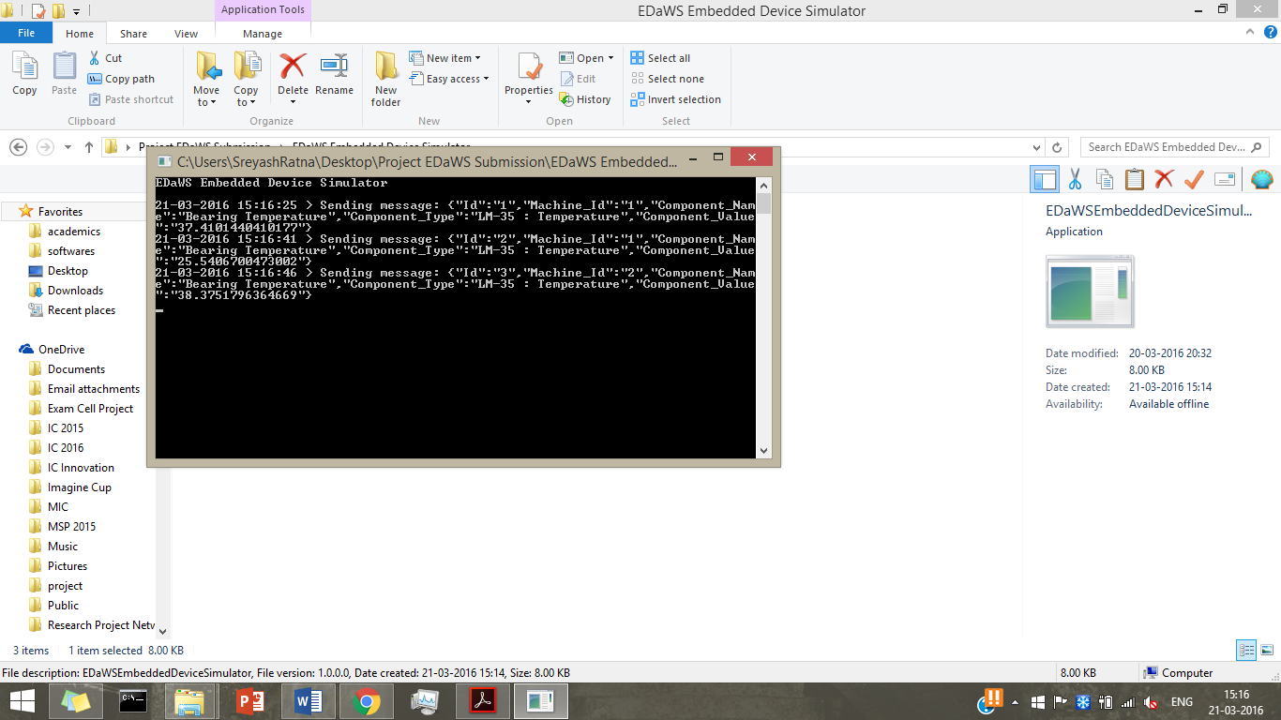
4. The screen shows the simulated data being sent from the embedded device to azure using Azure Events Hub.
5. Keep the window running and open the EDaWS Desktop App folder which contains the EDaWS_dsktp_mrk3_1.1.0.2_AnyCPU.appx file, Certificate file and other supporting files along with a sub folder AppPackages which contains all the packaged files from the application as generated.
6. Load and Run the Application. The first screen will look like this:  
   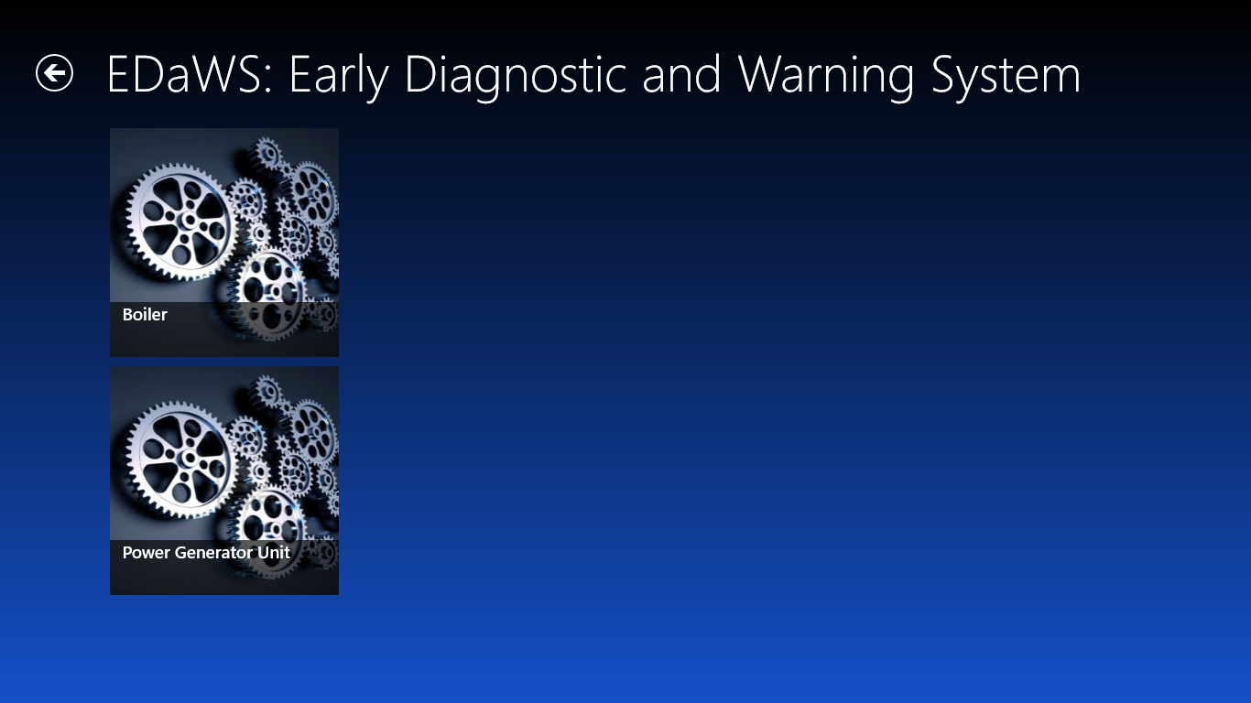  
   where the areas highlighted in red are the machines
7. For the purpose of this prototype, we have taken two simple machines. Click on any one of them. This will take you to a different page with the details of that machine.  
   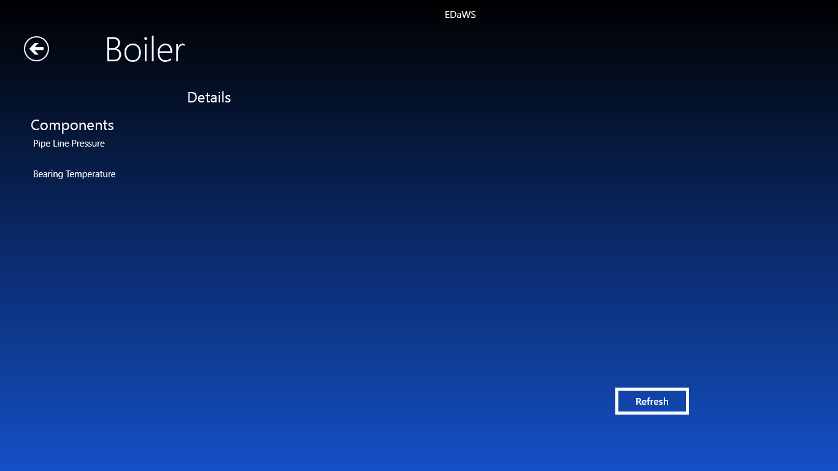
8. Click on any one of the Components to get the details of it.  
   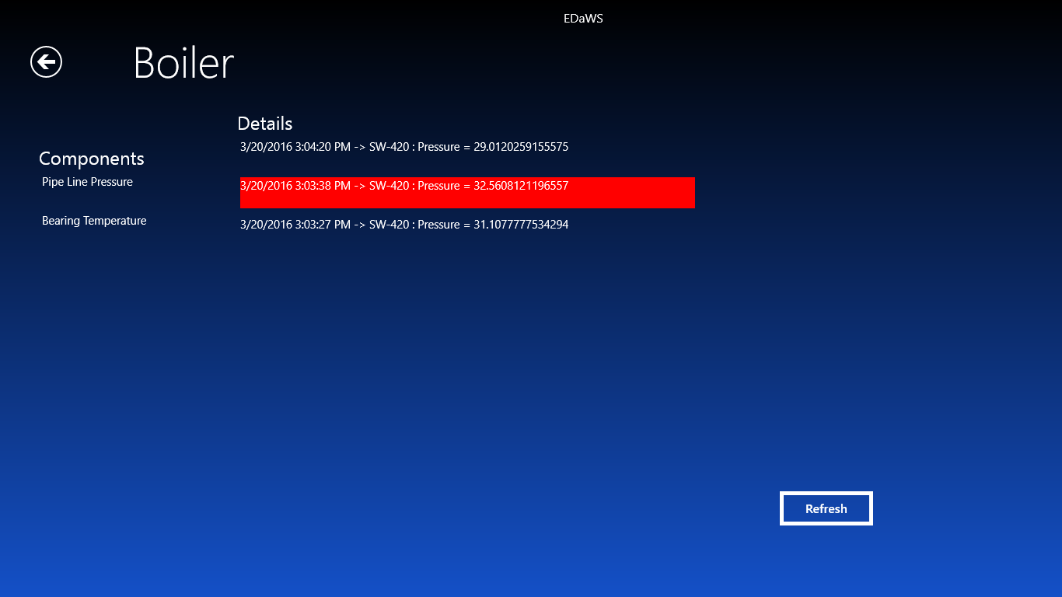
9. The data highlighted in red are the readings which are higher than the threshold value or are improper.
10. Click on Refresh and You will see an increase in the no. of readings. That is because the data is being taken in from cloud database using Azure Mobile Services.

# Windows Azure

The web tier of my project uses the following Azure services:

* Azure Mobile Service: <https://mobileservice-edaws.azure-mobile.net/>
* Primary Key: XkNbYXyWit6RnPNKENoqb41/A+jL0yewDF1AcqxcTBA=
* Azure SQL Server: svredaws.database.windows.net
* Azure Database Connection String: <!Sample String!>

Server=tcp:svredaws.database.windows.net,1433;Database=database-edaws;User ID=sreyashtripathi@svredaws;Password={your_password_here};Encrypt=True;TrustServerCertificate=False;Connection Timeout=30;

* Azure Stream Analytics: Currently Not Running